Chang Shu

[cshu1@kent.edu](mailto:cshu1@kent.edu)

Advanced Database System Design

Instructor: Dr. Gregory S DeLozier

ADSD Final Project Report

**1.Project overall**

My final project is to build and LBS (Location Based Server) iOS application. In this project, it will include Mongo DB, bottlepy REST API, iOS app. This LBS iOS application will send POST to web server API then web server will query the database on MongoLab, then return results and present on user’s devices.

This app will demo some features including: 1. Query nearby POI in some radius. 2. Get the distance between user’s location and other in-range POIs. 3. Order all the POIs according the distances from near to far. The the result will query from pythonanywhere web server, and sent to MongoLab database server.

**2.Project details**

**2.1 DB Design**

From bottom to top, I will step by step construct this whole application stack. First stuff needs to talk is the database. I’m working in project ParkApps(parkapps.kent.edu) currently. A lots of POIs store in a MySQL database. The instance in the location table structure like this:

|  |  |  |  |  |  |  |
| --- | --- | --- | --- | --- | --- | --- |
| id | longitude | latitude | title | description | link | type |

This project data will come from this MySQL database. Currently the SQL query statement is:

SELECT id, ( 6371 * acos( cos( radians(37) ) * cos( radians( lat ) ) * cos( radians

( lng ) - radians(-122) ) + sin( radians(37) ) * sin( radians( lat ) ) ) ) AS distance

FROM places HAVING distance < 25 ORDER BY distance LIMIT 0 , 100;

First part is to calculate the distance with (lon, lat) in select items. Then using order by distance to order the result set. This query needs lots of calculation and lots memory to order the result. Then I study the Mongo API for geo data, It’s perfect place for geo file storage and operation. Then I decide do final project to test all the operation on Mongo DB. The mongo db support a lot of complex operation on POI, like find nearby POI in circle area, or even in some polygon area. Like the figure in below.

This is all operation is on DB-level support to finish, you don’t need implement it by some complex algorithms, however you just need to learn API and get the result. It’s cool idea to do all operations in DB with encapsulate all process. Thus the query statement will be:

db.runCommand( { geoNear: "places", near: [ 121.4905, 31.2646 ], num:100 })

The pymonogo can easily to query by using this statements. The mongoDB has some optimization on DB level, even we don’t need to care about it under 1Million data level.

**2.2 API**

In the web server API part, there is a lot options. In last, I’m prefer php + nginx as web server. But after learn django I like it so much. It’s simple enough to do an simple demo without knowing too much API, the only thing is the concept how to design it. The pythonanywhere is a good place to as a temp place to host all the request service, and the configuration work is not hard. Thus in this project, I will choose bottlepy + pymongo.

The address is <http://changcode.pythonanywhere.com/nearbyAPI>. The request work is pretty straight forward. 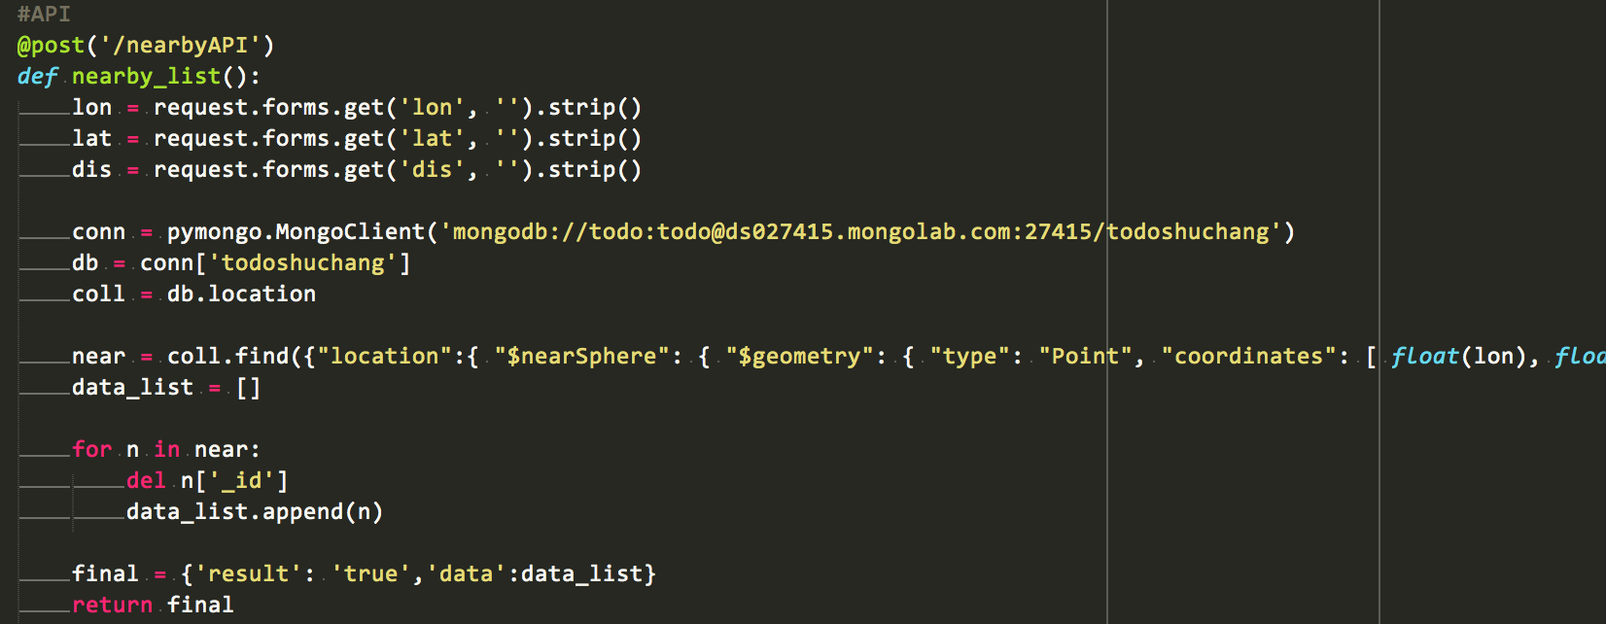

There are only three parameters needs to provide to the server, lon as longitude, lat as latitude, dis as distance. The center location can be represented as the (lon, lat), and the circle are can be present as (center, dis). Thus we can get the result through return results.

**2.3 Upper Apps**

In this part, I will use iOS app to test all previous work is working fine. Of course we can use google map or mapbox to show result on webpage by using this API(Probable as future works). In iOS app there are some stuffs unrelated to our course, but I need to explain here. The Cocoa framework provide some methods to send POST form in app so, this app can like web page working. Get the result and parse them to present all the data on the user’s screen. Finally this app woking like the figure show blow. User can adjust the radius and set different location to get the result.

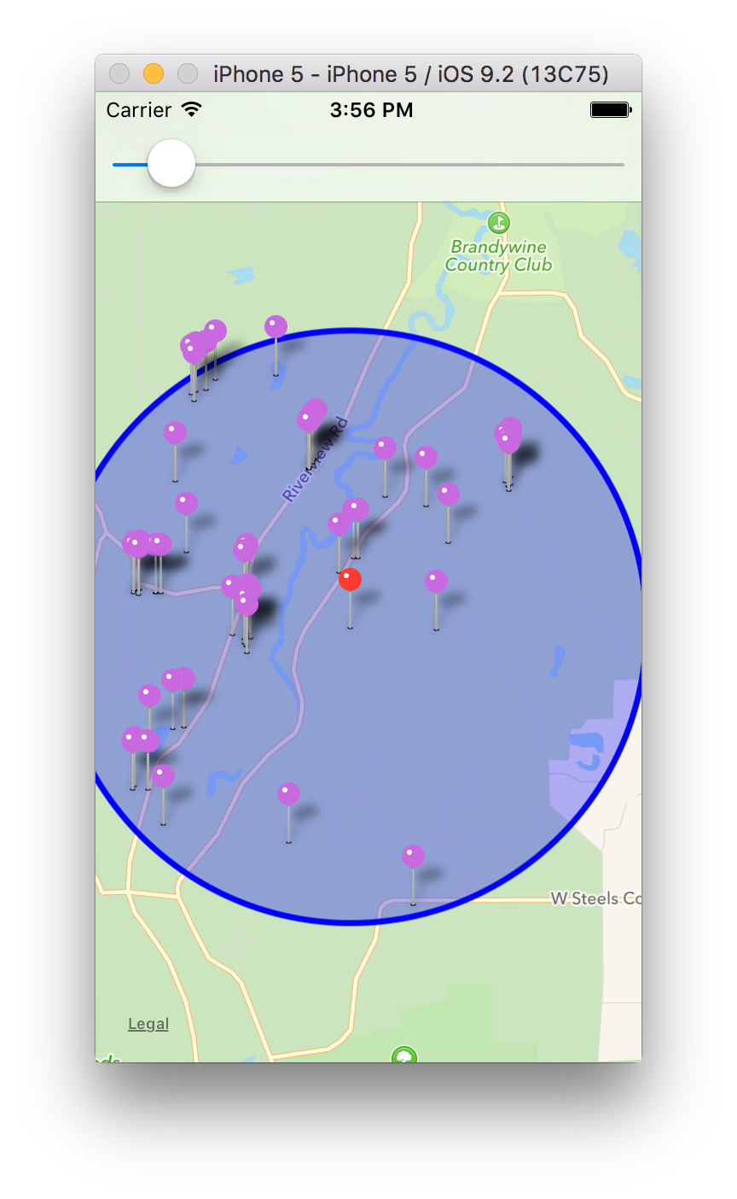

**3.Furture works**

As we can see the mongo DB working is prefect for the geospatial queries. I will try to do some analytics on comparing time executing the query when some area POI is crowded or sparse. The data set is about 1900 items in location collections, so I will put more data into this database to test the performance. There is some performance issue when dataset is keep growing to 1Million items by others article, I will try to verify it and migrate to local machine to test it.

**4.Anwser Parts**

1. What, exactly, is the project?

This project is focus on location base service app, try some POI operation on mongoDB through bottlepy and pymonog.

2. What does it do and how does it do it?

The development stack based on MongoLab + bottlepy(host on pythonanywhere) + Objective-C app. The app will send request to API on web server, web server send query to mongoLab. Then web server get the result and send it back to client.

3. Where did you get the idea?

In my working project Parkapps, and learn the mongo from ADSD.

4. Why is it interesting?

Because it opens my mind to think can do a lot of interesting stuffs base on this kind of LBS.

5. How does it use what we learned in class?

It including the MongoDB, ORM, bottle web server. In 2nd section of this report, I write more details about how use these techs.

6. What did you learn doing the project?

I learn how to use Mongo DB and the concept of ORM. The most important is how to make them working together.

7. If you were to continue this work, what is the next thing you would do, and why?

In 3th section of this report, I write the futures works about this project.